
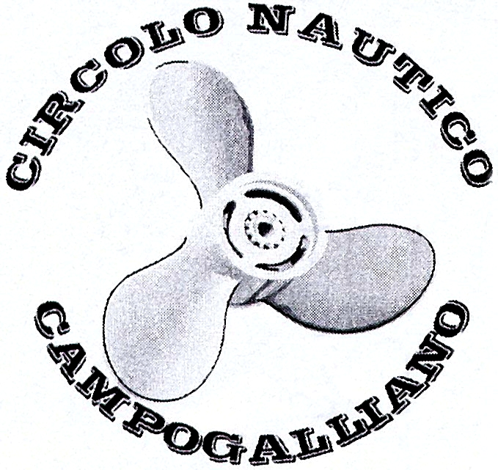
FEDERAZIONE
ITALIANA
NAVIMODEL

Rappr. ufficiale per l’Italia della Federazione Mondiale
di modelliamo navale NAVIGA


CON IL PATROCINIO DEL COMUNE DI CAMPOGALLIANO

organizzano

GARA INTERNAZIONALE AMICHEVOLE (OPEN)

3° Trofeo Navimodellistico
Città di Campogalliano

Promotive: FEDERAZIONE ITALIANA NAVIMODEL

Organizing Commitee: CIRCOLO NAUTICO CAMPOGALLIANO

Place: Campogalliano (Modena) - Panzano Lake (Via Canale Carpi)

Data: 29 / 30 April 2006

Entries: deadline 23 April 2006
Entry address:
Roberto Bigi - Via Zacchetti, 4/D - 42100 Reggio E. (Italia)

Tel. 0039/0522/921239 E-mail bigi.roberto@tiscali.it

Starting fee: 10 Euro first boat, 15 Euro for 2 or more boats.

Classes: FSR-E Mono 1/2/3 - Hydro 1/2/3 - Eco Expert
FSR-O 3.5 cc (Off-Shore)
F.1 3.5 cc. (Outboard Tunnel)

Rules: Naviga 01.01.06 for FSR-E classes
Naviga for FSR-O 3.5 cc. (5 minutes)
Navimodel for F.1 Outboard Tunnel 3.5 cc. (5 minutes)
(free fuel - free pipe).

All the classes (no Eco) will use the same oval circuit of 150 m.
(standard for FSR-E classes)

Frequency: 26.995 (4) - 27.045 (9) - 27.095 (14) - 27.145 (19)
(allowed in Italy) 27.195 (24) - 27.235 (28) - 27.275 (32) - 40.665 (50)
40.675 (51) - 40.685 (52) - 40.695 (53) - 40.715 (54)
40.725 (55) - 40.735 (56) - 40.765 (57) - 40.775 (58)
40.785 (59) - 40.815 (81) - 40.825 (82) - 40.835 (83)
40.865 (84) - 40.875 (85) - 72.080 (208) - 72.240 (224)
+ all 35 mhz frequency.

Prize: cups and medals + model equipment.

Conditions of admission: every owner of a model of the admitted classes can take part to the competition.

Free training: Friday from 09.30 AM to 06.00 PM.
Saturday from 09.00 AM to 10.30 AM for FSR-O and F.1 3.5 cc.
Saturday from 10.30 AM to 12.00 AM for FSR-E

Registrations: Friday all day and Saturday from 09.00 AM to 11.00 AM.

Opening competitions: Saturday 01.00 PM. Sunday 09.30 AM.

Break: only Sunday it’s possible to have a self service lunch in the park of the lake
(10 Euro)

Banquet: Saturday 29 April 2006 at 08.00 PM with typical food. (23 Euro)

Camping: free camping in the park of the Panzano lake.

Hotel: LA CORTE*** Via Brunelleschi, 3/B - 42048 Rubiera (RE)
(breakfast included) Tel. 0039 0522 627233 Fax 0039 059 627255
Single-room 55 E. Duoble-room 80 E. Triple-room 96 E.

LA GENTILE*** Via Martiri della Libertà, 21 - 41011 Campogalliano (MO)
Tel. 0039 059 525938 Fax 0039 059 526547
Single-room 42 E. Double-room 68 E. Triple-room 83 E.

Locanda Commercio Via G. Di Vittorio, 14/16 - 41011 Campogalliano (MO)
Tel. 0039 059 526917 Fax 0039 059 5221231
Single-room 50 E. Double-room 60 E. Triple-room 90 E.

Bed and Breakfast I PIOPPI Via Canale Carpi, 41 - 41011 Campogalliano (MO)
Tel. 0039 059 527498 E-mail callegari.michela@tiscali.it
call for informations (500 m. far from the lake)

It’s possible that the price of the Hotels will have a little increase

Informations: Roberto Bigi Tel. 0039/0522/921239 E-mail bigi.roberto@tiscali.it
www.comune.campogalliano.mo.it

Campogalliano it’s only few Km. apart from Modena.
Gate Campogalliano on the Brennero highway (A22). After the gate turn left.
At the second light turn left again and cross the bridge. At the second roundabaut turn right and follow the Carpi signs. 3 Km. after you can see the lake on your right.

MODULO D’ISCRIZIONE

3° Trofeo Navimodellistico Città di Campogalliano

Campogalliano (MO) Italia - 29/30 Aprile 2006

Cognome e nome / surname-name................................................................
Indirizzo / adress...........................................................................................
Nazione / land...............................................................................................

Classi / klass Frequenze (3) / frequenz (3)
Mhz Mhz Mhz
Mono 1 ............. ............ ............ ............
Mono 2 ............. ............ ............ ............
Mono 3 ............. ............ ............ ............
Hydro 1 ............. ............ ............ ............
Hydro 2 ............. ............ ............ ............
Hydro 3 ............. ............ ............ ............
Eco Expert ............. ............ ............ ............
FSR-O 3.5 cc. ............. ............ ............ ............
F.1 3.5 cc. ............. ............ ............ ............
(Outboard)

send to:
Roberto Bigi Via Zacchetti, 4/D - 42100 Reggio Emilia (Italia)

info. Tel. 0039/0522/921239 E-mail bigi.roberto@tiscali.it www.comune.campogalliano.mo.it

ATTENTION: we will organize only the race with 3 drivers at least.

Reservation banquet Saturday 29.04.06 (23 Euro) n........................................

Reservation self service Sunday 30.04.06 (10 Euro) n........................................

